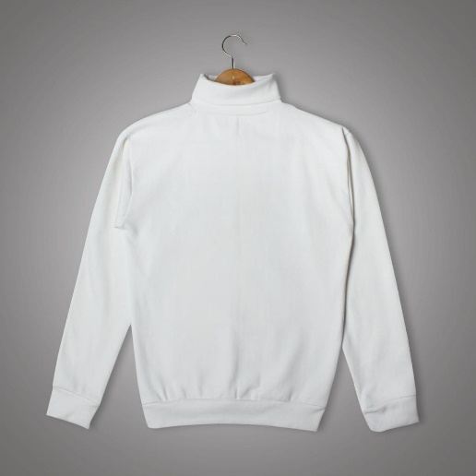

Oasis Fashion High Quality Casual Men Premium Black Full Sleeve Turtle Neck

Product details of Oasis Fashion High Quality Casual Men Premium Black Full Sleeve Turtle Neck

* Comfortable and versatile, this turtle neck is perfect on its own or as a layer under a blazer or jacke
* Size S >
* Chest : 17 to 20 inch .
* Lenght : 25 inch .
* Sleeves : 22 inch
* Size M>
* Chest : 19 to 23 inch .
* Lenght : 26 inch .
* Sleeves : 23 inch
* Size L>
* Chest : 21 to 25 inch .
* Lenght : 27.5 inch .
* Sleeves : 24 inch
* Size XL>
* Chest : 24 to 28 inch .
* Lenght : 228.5 inch .
* Sleeves : 25 inch
* Comfortable and versatile, this turtle neck is perfect on its own or as a layer under a blazer or jacke
  + Size S >
  + Chest : 17 to 20 inch .
  + Lenght : 25 inch .
  + Sleeves : 22 inch
  + Size M>
  + Chest : 19 to 23 inch .
  + Lenght : 26 inch .
  + Sleeves : 23 inch
  + Size L>
  + Chest : 21 to 25 inch .
  + Lenght : 27.5 inch .
  + Sleeves : 24 inch
  + Size XL>
  + Chest : 24  to 28 inch .
  + Lenght : 228.5 inch .
  + Sleeves : 25 inch